**Testing and Development:**

As I got into this project, it started becoming very straight forward. Once I understood the concept of a thread acquiring a lock, editing a shard variable, send a signal to other threads so they can do work on the shared variable and then releasing the lock.

The First step of this project was using the given simpleServer file to see how the connection process worked. I had to understand what was happening with this single connection if I was to allow the connection to support multiple clients on a single socket.

I then developed a spell checker unit that opened my specified dictionary file and went through it until it found a match or EOF, I decided to use a int 0 or 1 to show wrong or right. I also tested a thread unit. It created a thread pool that shared access to an array and printed each element in order. I tested these threads with and without locks to not only see how they behaved and confirm expectations but also learn how to correctly implement them. I should have tested signals as well.

From here, I combined the simpleServer file with my spell checker so that one client could connect, have a word checked and was then disconnected. I then added a while queue to keep this thread checking input until the user enter esc to disconnect. With this now successfully working, I began to implement the first producer/consumer problem. Here I noticed the server didn’t quit until I Ctrl+C’d but I ignored this, it did later cause problems with the log file editing.

Instead of declaring the socket connection variable as an int, it was turned into a circular array in which multiple connections to the same socket could be stored. I encountered a serious flaw here as I could not fill my connection socket array nor were threads picking up new clients that appeared to be waiting. This was because in my threads were not pthread_cond_signal’ing my connection thread to start working again. I also needed a second while loop in my thread to start consuming clients again if there were any or wait for a signal that says there are.

With a server that could now accept multiple clients on a single port, I began to implement a logger thread using the same logic and techniques used to implement my worker threads. I created a circular log array, the necessary locks and signals and implemented a single logger thread.

My first major problem came here. After implementing a function that passed the result of the spell check and placed it in a logger array, I was getting a segmentation fault after a single word was checked. I isolated my code line by line to find the issue was coming from how I was passing the data. My logger array was implemented as a single char array, it didn’t have the memory space to hold a string of unknow size.(I first completed this assignment by passing only an int to indicated right/wrong and it seemed to work fine so I knew the allocation of the string was the issue.) By mallocing space the size of the given string and mapping that space into my logger array seems to have solved that problem but I don’t ever free that space so I probably have that memory space still on my computer(I’ll figure that out).

Another problem was that the logger thread appeared to be constantly doing something. When I initially tested the program at this stage, it was creating huge blank log files. One problem was the conditions that my worker thread was looking for, I had to correct the conditions so it only worked when there was a log ready and not constantly. Once this was solved, I discovered my log file was never being written to as after I closed the program, the file always showed blank but I got a printout saying the logger was done. Adding a exit condition fixed this and my log file now compiled correct but showed the wrong correctness. This was a simple fix as I had the logger reading from the wrong correctness indicator.

I do remember getting bus error’s too. I don’t remember what was changed to fix these though but I assume it was related to how I first tried to solve the createLogEntry isssue

I Didn’t get many screen shots as I quite enjoyed this project. When presented with a issue, I went straight to finding a solution. Also the few I did take were hard to read and actually see what’s happening.

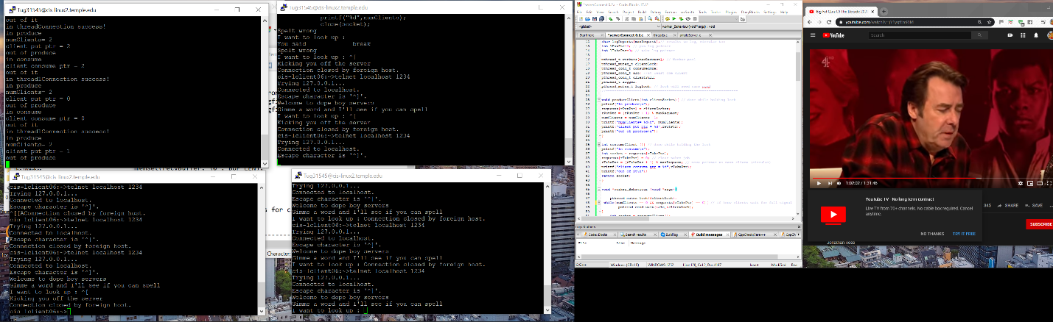

Multiple clients and wait queue working on socket but logger was not working due to exit cons

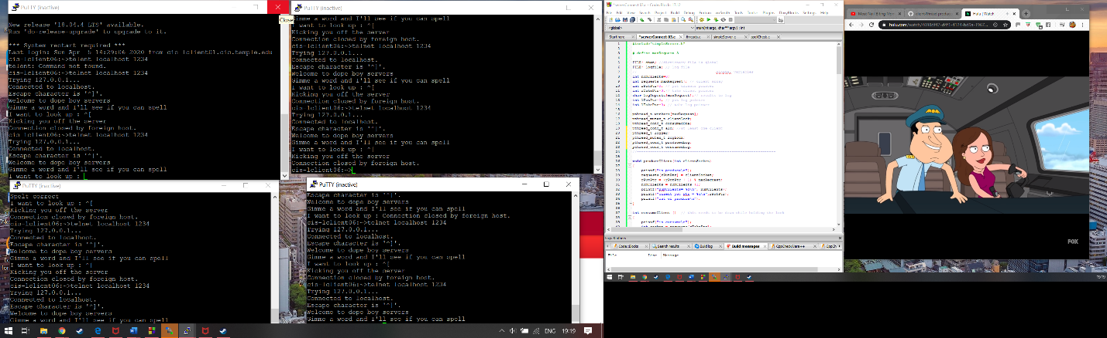

Finding seg fualt

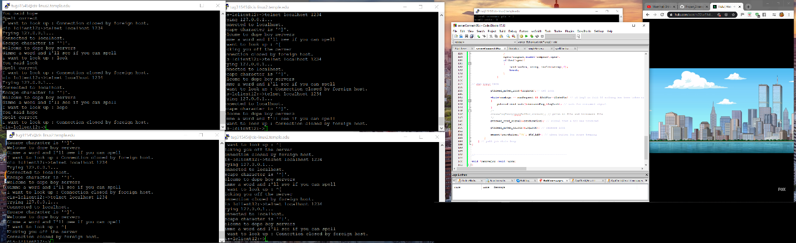

Successful execution with port specified

Inaccurate logger below

